School of Science, Computing and Engineering Technologies

Object Oriented Programming
Pass Task 2.2: Counter Class and Arithmetic Overflow-checking Overview


In this task you will create a Counter class and use it to create and work with Counter objects.
Purpose: Practice with properties and use object-oriented encapsulation. Task: Implement a program that creates and uses a number of counters to explore how objects work. The task contains personalized requirements.
Deadline: Due by the end of week three, Friday, 16 August 2024 (Firmed).

Submission Details
All students have access to the Adobe Acrobat tools. Please print your solution to PDF and combine it with the screenshots taken for this task.
- C# code files of the classes created.
- Screenshot of output.


Instructions
In this task you will create a Counter class and explore how fields can be used by an object to store and maintain information.
Each Counter object:
- Knows its count - by using a _count field to store an integer value,
- Knows its name - by using a _name field to store a string value,
- Can generated by using the constructor with a string parameter name that initializes the object's _count field to zero and sets the object's _name field to the value of name,
- Can increment object's _count field by one using the Increment method,
- Can reset itself by using the Reset method that sets the _count field to 0,
- Can give you its name via the Name property (i.e., get {…}),
- Can change its name via the Name property by assigning it a new value (i.e., set {…}),
- Can give you its value via the Ticks property (i.e., get {…}).
The following UML class diagram shows the basic outline for this class.
Counter
- _count: int
- _name: int
+ Counter(string name)
+ Increment()
+ Reset()
+ Name : string <<property>>
+ Ticks : int <<property>>
Note: The << … >> annotations in UML are known as stereotypes. They are used to add notes to aspects of the diagram. In this case, <<property>> notes that the Name attribute here is a property. Properties are virtual fields, that is, properties may or may not mapped to actual instance variables. Properties can be read-only, write-only, or read-write. In class Counter, property Name is read-write, whereas property Ticks is read-only.
- Create a new Console App and name it CounterTask.
- Create a new Counter class.
- Add the private _count and _name fields, enabling a Counter object to know its count and name values.
- Change the constructor so that it takes a string parameter that is used to set the _name field of the Counter object, and assign 0 to the _count field.
public class
Counter
{
private

int
_count;
private

string
_name;
public
Counter(
string
name)
{

_name = name;
_count = 0;
}

}
- Add the Increment method that increases the value of the _count field by one.
- Add a Reset method that assigns 0 to the _count field.
You have now created the code needed to work with Counter objects. Each Counter object knows its count and name and can increment and reset its count value. Notice, the things a Counter object knows are hidden within the object (due to the private modifier on the fields). This is one of the guiding principles of object-oriented encapsulation. Object-oriented encapsulation is a mechanism that allows you to hide specific information and control access to the object’s internal state. In general, you achieve object-oriented encapsulation by making all instance variables private, and provide read or write access to instance variables via public methods only.
The keywords private and public serve as scope modifiers in C#. A feature marked private is only visible within the scope of the defining class and its objects. Features marked public are visible to all clients of a class and its objects. The term client refers to other classes, other objects, and even other applications. You should aim at achieving a suitable balance between public and private visibility within a class and its objects. Object-oriented encapsulation is not a mechanism whose principles are set in stone – sometimes it can be beneficial to loosen access restrictions if the domain abstraction calls for it.
C# includes a feature, called properties, that allows you to provide access to data in a controlled way. From the outside, properties look and feel like instance variables of an object. Hence, they are also known as virtual fields. However, properties are actually mapped to a pair of methods: get – to retrieve a value, and set – to update a value. Properties are not simply used to provide access to instance variables. Instead, you often use properties to perform safety checks or compute composite values for a set of attributes.
- Create a Name property for Counter objects using the following code:
public class
Counter
{
private

string
_name;
public

string
Name
{

get

{

return
_name;
}

set

{

_name = value;
}

}

}

Properties have the general format as shown below. However, you can add any code you want within the get and set methods, as long as get returns a value and set changes a value.
public

[
TYPE
]
PropertyName
{

get

{

return
…
}

set

{

… = value;
}

}

- Create the Ticks property for the Counter class. Ticks is a read-only property that returns the value of the _count field.
Hint
:
Read-only properties have only a
get
method, write-only properties have only a
set
method.
Your Counter class is now complete. Build your solution and fix any error before you proceed.
- Return to the Program.cs file.
- Implement the following pseudocode for the static method PrintCounters method:
PrintCounters(counters)
1: // parameter counters is an array of Counter objects
2: foreach c in counters
3: Tell Console to WriteLine with the format “{0} is {1}”
4: and the result of Tell c to Name
5: and the result of Tell c to Ticks
Tips:
To declare a static method, you need to annotate the signature of the method with the keyword static. For example, static public void Print ( string[] names ) { …}
Foreach loops are a simple way of traversing over all of the elements of an array in C#. For example foreach (string name in names) { … }
The loop variable c in the pseudocode is a Counter object. In C#, you need to write Counter c so that the loop variable has a proper type.
Note: Console's WriteLine method can take a variable number of parameters. The {0} marker means inject the 1st value following the string at this point. For example:
Console.WriteLine("Hello, {0}{1}", "World", "!");
Please note, both Main and PrintCounters are static methods. Static methods are not associated with any object. Hence, you do not need to create a Program object to use PrintCounters.
internal class
Program
{

private

static void
PrintCounters(Counter[] counters)
{
… }
static void
Main(string[] args)
{
… }
}

11. Use the following pseudocode to implement the Main method.
Main()
1: Let myCounters be an array of three Counter objects
2: myCounters[0] := new Counter with name “Counter 1”
3: myCounters[1] := new Counter with name “Counter 2”
4: myCounters[2] := myCounter[0]
5: for i := 1 to 9
6: Tell myCounters[0] to Increment
7: for i := 1 to 14
8: Tell myCounters[1] to Increment
9: Tell Program to PrintCounters(myCounters)
10: Tell myCounters[2] to Reset
11: Tell Program to PrintCounters(myCounters)
In pseudocode, a for i:= 0 to 3 statement has four iterations: i == 0, i == 1, i == 2, and i == 3.
How many iterations does for i:= 1 to 4 have?
Hint:
You can declare the array using
Counter[] myCounters = new Counter[3];
- Create a new Reset method, named, ResetByDefault, in the Counter class to reset the corresponding count to the integer valued at 2147483647XXX, where the XXX is the last three digits of your student ID.
- Tell the Counter to increase the count value. Does the code still run without any bugs/crash? What is the reason behind? You can provide the answers as the comments in the code.
Hint. Please read Microsoft Learn portal
https://learn.microsoft.com/en-us/dotnet/csharp/language-reference/ statements/checked-and-unchecked
- Compile and run your program.
Once your program is complete you can prepare it for your portfolio. This can be placed in your portfolio as evidence of what you have learnt.
  - Review your code and ensure it is formatted correctly.
  - Run the program and use your preferred screenshot program to take a screenshot of the Terminal showing the program's output.
  - Save and backup your work to multiple locations, if possible.
    - Once you your program is working you do not want to lose your work.
    - Work on your computer’s storage device most of the time, but backup your work when you finish each task.
    - You may use a cloud storage provider to safely store your work.
    - USB and portable hard drives are good secondary backups, but there is a risk that the drive gets damaged or lost.
Note
:
Each week you should aim to submit
all tasks.
Submit
this task once it is complete.
The assessment criteria give you a list of things to check before you submit.

Assessment Criteria
Make sure that your task has the following in your submission:
- The “Universal Task Requirements” (see Canvas) have been met.
- Your program (as text or screenshot).
- Screenshot of output.
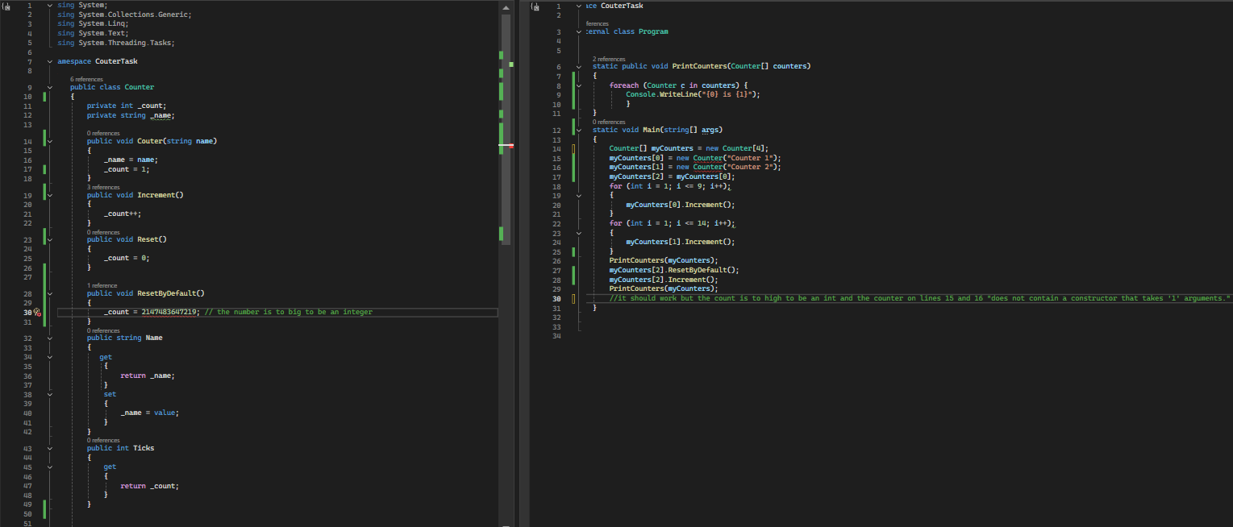
Output:
